Title: Competition
Subject: EEP 9

1. We love competition hence we need rules  A. Components of Eu competition legislation  B. Institutions and instruments  C. Scope  3. Antitrust  A. Agreements between firms  a. Nothing Strange  b. Vertical, horizontal agreements and collusion  d. Ec job  B. Abuse of dominant position  a. What makes a dominant position  b. Abuses of dominant position  4. Concentrations (M&As)  5. State Aids  a. What are they  b. Procedure  d. Example  e. State aid creates problems for the Eu | We love competition bc it ensures efficient resource allocation. BUT mkt must be regulated to be free: firms must fight in a level-playing field. Us were the first to understand already in the 19th century (Sherman Act 1890) = we copied from the Us  a. Eu competition legislation encompasses  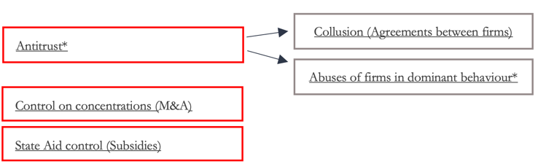  *¹ A lot of cases are affecting non eu countries = soft power  *² It is not necessarily against monopolies: not necessarily be dangerous for consumers (economies of scale, contestable markets, innovation). A case-by-case approach is needed (only few per-se prohibitions).  b. TFEU defines institutions and instruments though wich eu legislation can reach its objectives  TFEU: EC is the Institution responsible for managing competition policy . The Commission has a wide range of inspection and enforcement powers (investigate, hold hearings, impose fines and grant exemptions). Under a system of checks and balances, the EC’s decisions can be challenged in the General Court with a final appeal before the Court of Justice.  c. TFEU also defines the scope of application of its legislation  TFEU: EU rules apply only when a competition issue concerns practices which are capable to “affect trade between Member States” (Two Italian companies merge but they do not affect in any way eu mkt --> no eu jurisdiction). Community dimension, marking the boundary between the European and the national competition legal frameworks (don’t forget the principle of subsidiarity)  AGREEMENTS BETWEEN FIRMS / COLLUSION  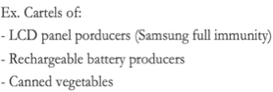  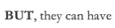  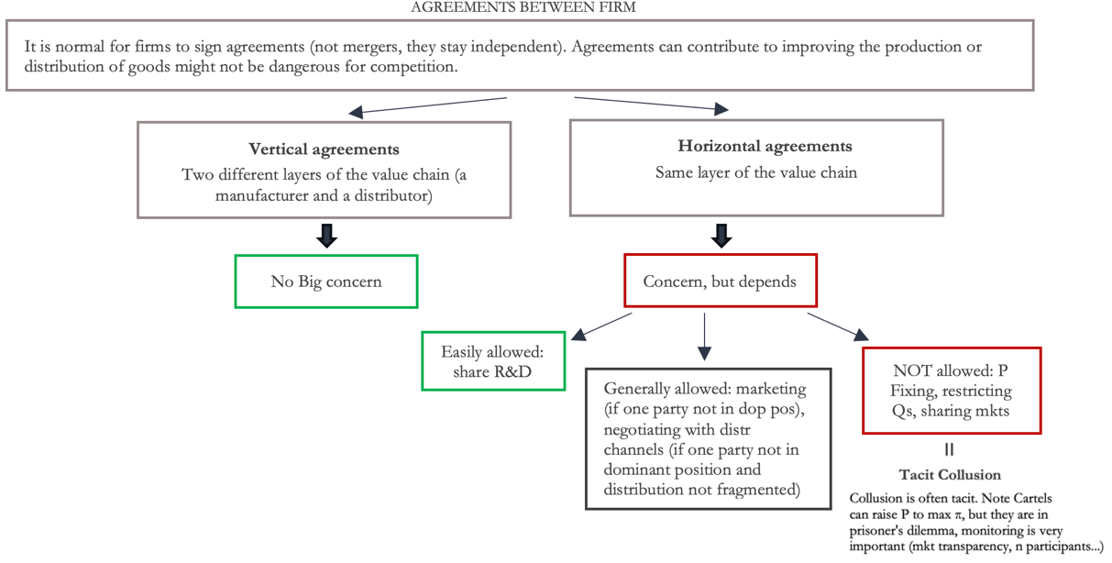  Procompetitive effects When the agreement helps the supplier enter a new mkt.  Anticompetitive effects When the agreement contains restraints on the distributor (ex. obligation not to purchase competing brands or to only supply only one buyer (exclusive supply).  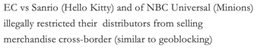  *Agreements on prices, exchanges of sensible commercial informations (S and D forecasts, price forecast, production planning, capacity utilization), agreements to avoid competition, agreeements on market shares and volume quotas  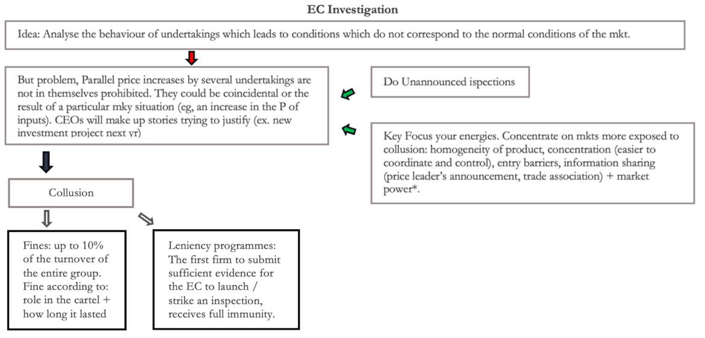  *Issue of definition of the relevant market! You have to define which is:  i. The product mkt: considered what are the substitues for that product = you have to understand wheter a P $↑$ is profitable or not = if profitable they aren’t substitutes. Ex. Mkt for Bananas tend to have low elasticity (SSNIP test, cross-price ε (if >0 they are substitutes))  ii. The geographic market: mkt for concrete is concentrated, mkt for airplanes is global  The supply of many goods is more concentrated than we would think, ex. car: big expenditure, you can drive it, but you do not consider often to buy it in Croazia. Size of the market is in inverse proportion to: the product’s transportation costs / the value of the product  ABUSE OF DOMINANT POSITION  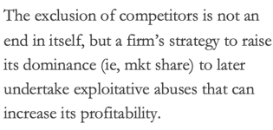  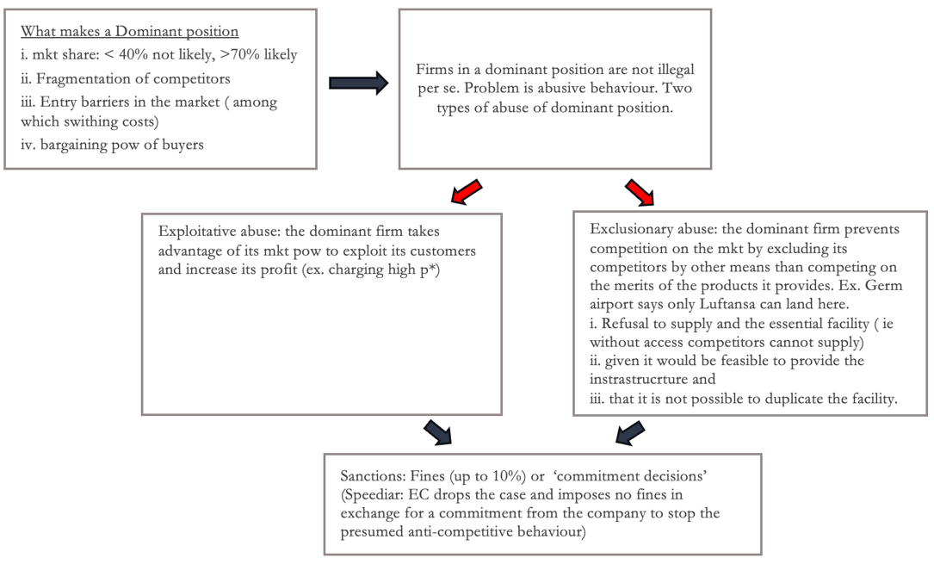  * Note: Price discrimination is not illegal per se. Price discrimination is not prohibited if it is justified by cost differentials (eg in 2 different countries). Homogeneous prices can be harmful, especially for consumers in less wealthy countries. Iphone with different p in uk and fra, good as long as you are in uk and you can but it in the fra website  i. Microsoft: Tying, PCs and apps are two seprate products, Microsoft did not give customers psossibility to obtain the tying product without the tied product (pre-installed) hence foreclosing competition.  ii. Google: exclusionary abuse  - Case #1 Google Shopping (own products at the top)  - Case #2 Android (tying)  iii. Amazon: as a matching platform has possibility to monitor supply and demand dynamics in its market, number of pruchases, sellers’ revenues on the marketplace, number of visits etc => Entered strategically the market  a. Idea  M&A: two or more independent undertakings merge into a single entity. Can be horizontal or vertical.  Pros: Combining the activities of different companies may allow the companies, to develop new products more efficiently or to reduce production or distribution costs => benefit consumers  Cons: creates concentration.  b. Procedure:  - Concentration (above certain thresholds) must be notified to the EC prior to its implementation.  - Requests for information from the merging companies or third parties;  - Questionnaires to competitors, customers and other market participants  - Calculation of market shares (HHI)  c. EC approach: If the merge impedes competiton by the creation of a dominant position, it is incompatible with the common market.  d. Motivations: Generally EC is aware of the benefits linked to merging processes (prohibits < 1% of requests). Firms have to provide the right motivations:  i. Efficiency defence  ii. Failing firm defence. Aprilia-piaggio: Piaggio, Aprilia is going to fail anyways ( and the market will lose one player)  iii. Remedies/commitments. The firms can propose solutions to keep a sufficient degree of competition in the market (eg, by selling asset or favouring the entrance of new competitors ex. windTre or Ita-KLM). There could be negotiation  a. Idea: State aid is an advantage conferred on a selective basis to undertakings by public authorities  b. Procedure: need of prior notification of all new aid measures to the EC. Member States must wait for the EC decision. Except:  Aid granted under an aid scheme already authorized by the Commission.  The minimis aid not exceeding 200,000 EUR per undertaking over any period of 3 fiscal years or  Aid covered by a Block Exemption, giving automatic approval for a range of measures defined by the EC (eg, local transport, broadband..)  There are a few exceptions to mandatory notification, for example:  c. EC approach: Note that if gov. decreases atx reate for every firm operating in the market there is no problem. The problem is there is the measure is selective. Exceptions:  Exceptions  State aids can be legal (notified and approved by the Ec) if they promote:  State aids are always legal when they have a social character (granted to individual consumers without discrimination related to the origin of the products concerned) and in case of natural disasters.  Promote merit goods (of key importance as education, health care ) by covering a mkt failure  Culture and heritage conservation.  Execution of an important project of common European interest  Economic Dev in areas where the standard of living is abnormally low / there is serious u  e. Example: IRL-APPLE  - 2016: EC concludes that two tax rulings issued by Ireland to Apple have lowered the tax paid by Apple in Ireland (All profits of Apple in Eu are recorded in Ireland) since 1991. Basically IRL gov had successfully negotiated a selective reduction in tax rate paid by apple.  => EC opposed this  f. State Aid and the European green deal  2023: The EC adopted a Temporary Crisis and Transition Framework (TCTF) to foster support measures in sectors that are key for the transition => flexibility in state aid for batteries, solar panels, hydrogen, zero emission vehicles etc. Need to contrast the unfair subsidies of the Us IRA. Ex. Northvolt is a Swedish firm committed to manufacturing EV batteries with the lowest embedded carbon content. Northvolt announced that it wanted to build a factory in Quebec (it would have benefited of IRA) => The European Commission approved a €902 million German measure to support Northvolt.  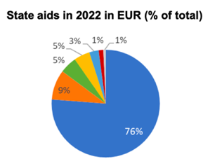  BUT  State aids may increase inequality within the Eu! Some countries are significantly more financially constrained than others (do not have the same fiscal capaity) = lack the resources needed to found new subsidies schemes!  => Need of a common Eu fund!

